

ABOUT US

Exigencies Mercantile India Private Limited is a diversified mercantile and strategic business solutions company committed to enabling global and domestic enterprises to successfully enter, operate, and expand within the Indian market.
We specialise in brand and OEM representation, general trading, industrial and construction solutions, scrap trading, land acquisition & investment, and liaisoning & representation services — delivering integrated, single-window support to our partners across India.
With deep market knowledge, a compliance-first approach, and an extensive network of suppliers, distributors, and industry professionals, we bridge the gap between opportunity and execution. Our team combines strategic planning with hands-on operational capability to ensure that every project is implemented efficiently, transparently, and in full alignment with regulatory requirements.
At Exigencies Mercantile India Private Limited, we believe in building long-term partnerships rooted in trust, integrity, and measurable performance. Our focus is not just on facilitating transactions — it is on creating sustainable value and lasting growth for every client we serve.

6  Service Verticals | Pan-India  Market Reach | 100%  Compliance-First | OEM  Specialists

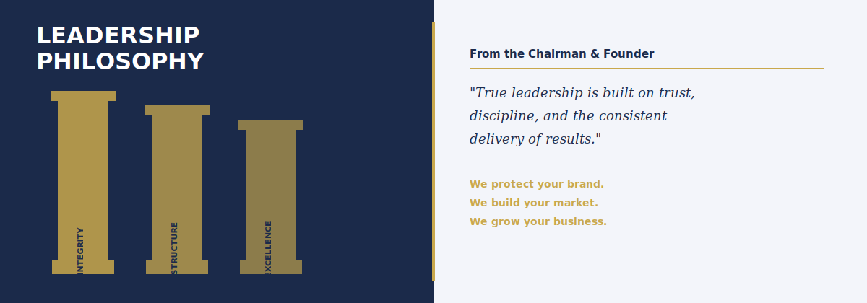

CHAIRMAN & FOUNDER'S MESSAGE

At Exigencies Mercantile India Private Limited, our journey is guided by a simple, yet powerful belief — true leadership is built on trust, discipline, and the consistent delivery of results.
India today stands at a historic inflection point. It is rapidly emerging as a global manufacturing hub, an infrastructure powerhouse, and a high-growth consumption market. For international OEMs, India presents exceptional opportunity. However, realising this potential requires more than market access — it requires a partner who understands the landscape, navigates complexity, ensures compliance, and executes with precision.
We founded Exigencies Mercantile India Private Limited with the conviction that global enterprises deserve a single-window, strategic partner in India — one that combines deep local intelligence with international business standards.

Our Leadership Philosophy
Our approach is anchored in three core pillars that govern every engagement, every strategy, and every outcome we deliver:

Integrity  in Every Engagement | Structure  in Every Strategy | Excellence  in Every Execution

We do not view ourselves as intermediaries. We position ourselves as long-term partners — responsible for building markets, establishing operations, and creating sustainable business foundations for every brand and OEM we represent.
From market-entry strategy and regulatory compliance to trading operations, construction machinery lifecycle support, and industrial partnerships, our approach remains disciplined, transparent, and performance-driven.

For international OEMs seeking to enter or expand in India, our commitment is clear:
We will protect your brand. · We will build your market. · We will grow your business.

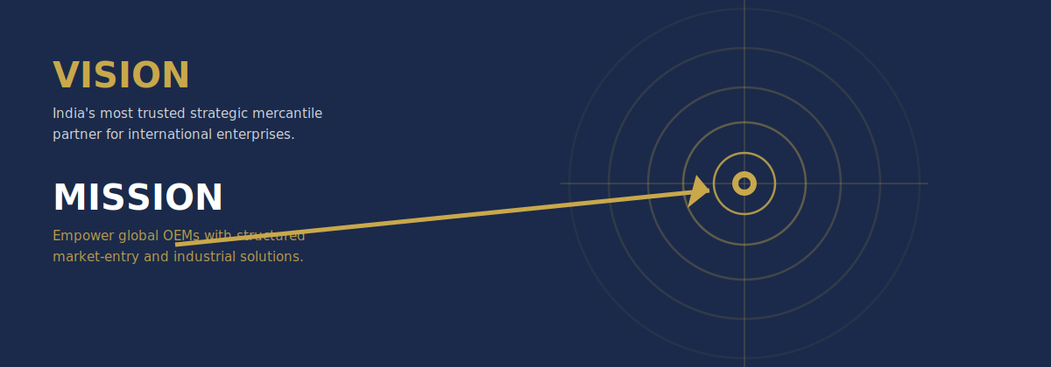

VISION & MISSION

OUR VISION  To become India's most trusted strategic mercantile partner for international enterprises — recognised for integrity, execution strength, and our ability to transform global ambitions into successful Indian operations.  – Reputation built on results, not promises  – Partnerships grounded in transparency  – Benchmark for governance in mercantile services  – Preferred gateway for global enterprises | OUR MISSION  To empower international OEMs and global enterprises with structured market-entry, representation, trading, and industrial solutions in India — through compliance-driven execution, strategic foresight, and operational excellence.  – Single-window access to India's complex market  – Clarity and accountability at every stage  – Local expertise meets global governance standards  – Full regulatory compliance from day one

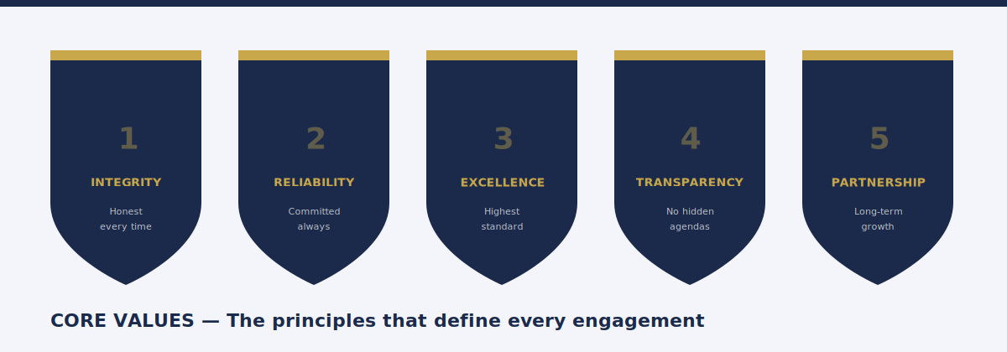

CORE VALUES

Our core values are not aspirational statements — they are the operating principles that guide every decision, every client engagement, and every outcome we produce.

Integrity | We conduct every engagement with absolute honesty, ethical discipline, and full transparency. Our partners trust us because we say what we mean and do what we say — without exception or compromise.

Reliability | Commitments made are commitments kept. We build our reputation on consistent delivery — on time, within scope, and to the highest quality standard, regardless of the complexity involved.

Excellence | We hold ourselves to the highest standard in everything we do — from strategic planning and compliance management to daily client communication and operational execution in the field.

Transparency | We maintain open, honest, and proactive communication with all stakeholders. There are no hidden agendas and no surprises — only clear, timely, and accurate information at every stage.

Partnership | We view every client relationship as a long-term partnership, not a transaction. We align our objectives with yours, invest in your success, and measure ourselves by your sustainable growth.

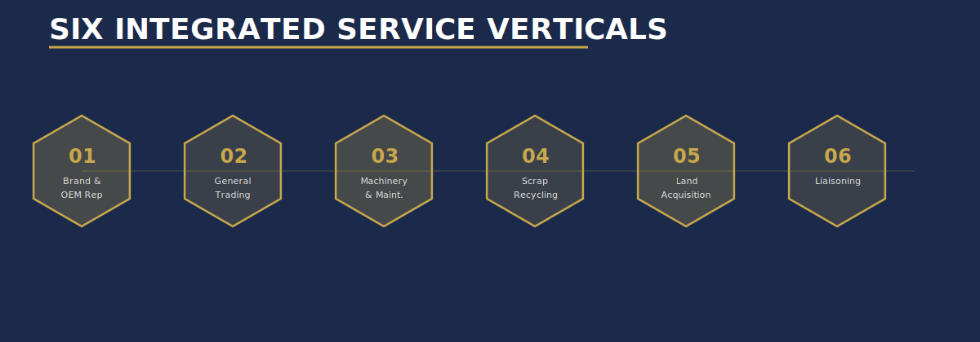

OUR SERVICES

We deliver six integrated service verticals designed to provide global and domestic enterprises with end-to-end market access, operational infrastructure, and sustainable growth in India. Each service is structured around a compliance-first engagement model.

01 | Brand & OEM Representation

We serve as the authorised strategic partner for international and domestic brands entering or expanding in India. Our representation extends far beyond basic agency agreements — we assume full commercial, operational, and compliance responsibility for your brand in the Indian market.
- Market entry strategy, feasibility assessment, and regulatory pathway mapping
- Company incorporation, branch office or liaison office establishment
- Product registration, import licensing, and statutory approvals
- Distributor, dealer, and channel partner identification and onboarding
- Sales force setup, training, and performance management
- Brand protection, IP filing, and trademark registration support
- After-sales service infrastructure development and localized marketing

Market Entry | Compliance | Channel Development | Brand Protection

02 | General Trading — Food & Industrial Products

We facilitate domestic and cross-border trade across a wide range of food and industrial products, operating across the full supply chain — from sourcing and quality control through to logistics and regulatory compliance. Our trading operations are structured for reliability, traceability, and efficiency.

- Sourcing of raw, unprocessed, processed, and frozen food products
- Agricultural commodities — spices, grains, pulses, and packaged goods
- Industrial goods procurement: consumables, components, and MRO supplies
- Supplier qualification, vendor audits, and quality assurance protocols
- Cold chain logistics, warehousing, and temperature-controlled distribution
- Import/export documentation, customs clearance, and FSSAI compliance

Food Products | Industrial Goods | Quality Assurance | Logistics

03 | Construction Machinery, Maintenance & Rebuilding

We provide comprehensive lifecycle support for construction and heavy equipment — from procurement and market entry to scheduled maintenance, emergency breakdown support, and full equipment rebuilding. Our approach maximises asset utilisation and extends equipment service life.
- Supply of construction machinery — earthmoving, road, lifting, and compaction equipment
- Genuine spare parts sourcing and inventory management
- Preventive maintenance scheduling and breakdown emergency response
- Full equipment overhaul, rebuilding, and performance restoration
- Operator training, safety compliance programmes, and fleet management
- OEM warranty coordination and technical documentation support

Machinery Supply | Preventive Maintenance | Breakdown Support | Rebuilding

04 | Scrap Trading & Recycling

We facilitate the responsible sourcing, trading, and recycling of ferrous, non-ferrous, and industrial scrap materials. Our operations support sustainable material recovery and circular economy practices while ensuring full compliance with environmental and regulatory standards.
- Ferrous scrap: HMS, shredded steel, cast iron, structural scrap, and turnings
- Non-ferrous scrap: aluminium, copper, brass, zinc, lead, and stainless steel
- Industrial scrap: e-waste components, machinery scrap, and plant dismantling
- Vendor identification, material assessment, grading, and pricing
- Weight certification, laboratory testing, and environmental documentation
- Export consignments — packing, containerisation, and customs clearance

Ferrous & Non-Ferrous | Industrial Scrap | Eco-Compliance | Export Ready

05 | Land Acquisition & Investment

We provide end-to-end advisory and execution support for commercial property acquisition, land investment, and real estate development across India. Our services are designed for industrial enterprises, OEMs, retailers, and investors seeking structured, compliant access to the Indian real estate market.
- Site identification and location feasibility analysis
- Title verification, encumbrance search, and full legal due diligence
- Zoning, land use, and regulatory approval assessment
- Negotiation support and transaction structuring
- Showroom, warehouse, and industrial shed acquisition
- Commercial land parcels for manufacturing or logistics development
- Liaisoning with government bodies for all required approvals and registrations

Site Identification | Due Diligence | Transaction Support | Approvals

06 | Liaisoning & Representation

We serve as authorised representatives for corporate entities requiring professional coordination with government bodies, regulatory authorities, and industry stakeholders. Our liaisoning capabilities are built on established relationships, deep procedural knowledge, and a compliance-first approach.
- Government department coordination — central and state ministries
- Regulatory approvals, NOCs, and clearance facilitation
- Municipal and local body liaisoning for permits and inspections
- Corporate representation for meetings, hearings, and negotiations
- Public sector procurement — documentation, bidding, and follow-up
- Statutory filing coordination and compliance monitoring

Govt Relations | Regulatory | Corporate Rep | Statutory

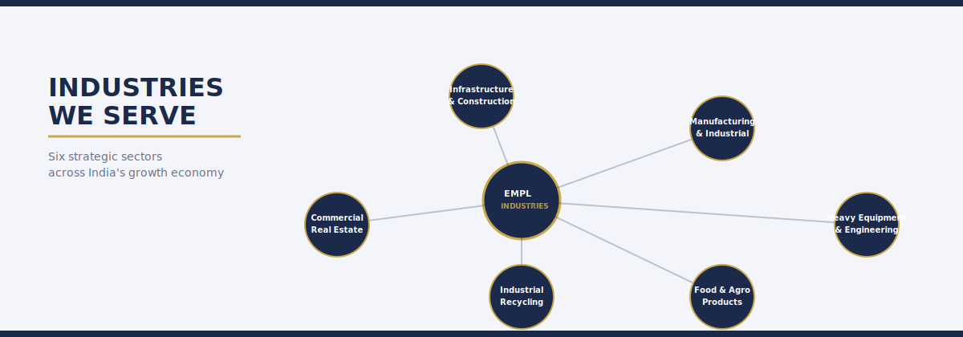

INDUSTRIES WE SERVE

Exigencies Mercantile India Private Limited operates across a broad and strategically selected range of industries. Our cross-sector expertise enables us to bring market-entry intelligence, operational know-how, and compliance capabilities that are relevant, current, and industry-specific.

Infrastructure & Construction
India's infrastructure sector is experiencing unprecedented investment under the National Infrastructure Pipeline (₹111 lakh crore). We support developers, contractors, and equipment suppliers with machinery procurement, maintenance, and market-entry solutions.
✔ Construction machinery supply and lifecycle support
✔ Spare parts sourcing and inventory management
✔ Subcontractor and vendor identification
✔ Regulatory and statutory project compliance

Manufacturing & Industrial Production
India's manufacturing sector is being transformed by PLI schemes and the Make in India initiative. We enable international manufacturers and OEMs to establish, localise, and grow operations — managing representation, compliance, and channel development on their behalf.
✔ OEM market entry and brand representation
✔ Supplier and vendor network development
✔ Industrial sourcing and procurement
✔ Compliance with manufacturing regulations

Heavy Equipment & Engineering
The heavy equipment and engineering sector is expanding rapidly, driven by infrastructure, mining, and energy projects. We provide market development, lifecycle maintenance, and distribution support — ensuring equipment remains productive and market presence grows sustainably.
✔ Authorised brand and product representation
✔ Dealer and service network establishment
✔ Spare parts distribution and availability management
✔ Operator training and safety compliance

Food & Agro Products
India is one of the world's largest producers and consumers of agricultural products. We facilitate compliant, efficient trade in food and agro commodities — connecting suppliers, processors, and buyers with quality assurance and regulatory expertise.
✔ Raw and processed food commodity trading
✔ FSSAI compliance and food safety management
✔ Cold chain and perishable logistics coordination
✔ Export documentation and international trade support

Industrial Recycling & Scrap
We support the industrial recycling ecosystem by facilitating the sourcing, grading, and trade of ferrous and non-ferrous scrap — enabling manufacturers to access secondary raw materials efficiently, responsibly, and within all regulatory requirements.
✔ Material sourcing from certified generators
✔ Laboratory-certified quality assessment and grading
✔ Compliance with environmental and pollution control norms
✔ Export consignments and customs clearance

Commercial Real Estate & Investment
India's commercial and industrial real estate market offers significant opportunities for enterprises seeking to establish operations or expand. We provide structured advisory and execution support — from site identification and due diligence through to transaction completion.
✔ Industrial land and factory premises acquisition
✔ Retail showroom and commercial space procurement
✔ Investment advisory for land and development projects
✔ Title verification, legal due diligence, and approvals

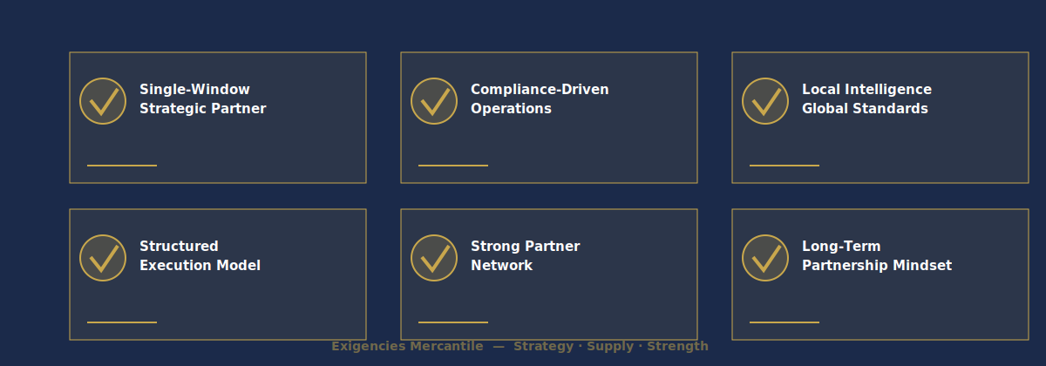

WHY CHOOSE US

In a market as complex and dynamic as India, the quality of your local partner determines the quality of your outcomes. At Exigencies Mercantile India Private Limited, we offer a combination of capabilities, values, and experience that sets us apart.

✔ Single-Window Strategic Partner
India's business environment involves multiple stakeholders, authorities, and regulatory frameworks. We consolidate this complexity into a single, accountable partnership — providing integrated market-entry, representation, trading, compliance, and industrial solutions under one platform. This eliminates the need to manage multiple vendors and agencies, reducing coordination costs, timelines, and execution risk significantly.

✔ Compliance-Driven Operations
Regulatory non-compliance is the single greatest risk to any enterprise operating in India. We have built compliance into the DNA of our operations — not as a checkbox exercise, but as a core discipline. From GST and import regulations to environmental clearances and industry-specific licensing, every engagement we undertake is fully compliant with all applicable legal and statutory requirements.

✔ Local Intelligence, Global Standards
Effective market entry in India requires deep local intelligence — an understanding of regional dynamics, regulatory nuances, cultural considerations, and stakeholder relationships. We combine this on-the-ground expertise with internationally recognised business governance standards, ensuring clients benefit from local know-how without sacrificing the rigour they expect from a world-class partner.

✔ Structured Execution Model
We operate through a defined, phased engagement model — from initial market assessment through strategy, setup, launch, and scale. At every stage, roles are clearly defined, timelines are established, and progress is tracked against measurable milestones. This eliminates ambiguity, maintains accountability, and ensures full client visibility at all times.

✔ Strong Partner & Distribution Network
We maintain established working relationships with a broad network of suppliers, distributors, logistics providers, legal advisors, regulatory consultants, and industry stakeholders across India. This network enables faster execution, competitive sourcing, and better outcomes — advantages that would take years for a new entrant to build independently.

✔ Long-Term Partnership Mindset
Our commercial model and culture are aligned around long-term value creation, not short-term transactions. We invest deeply in understanding our clients' businesses, align our objectives with their strategic goals, and build engagements designed to scale sustainably. Our success is measured by your growth — and that is how we operate every day.

Our Promise
We protect your brand. · We build your market. · We deliver your growth.

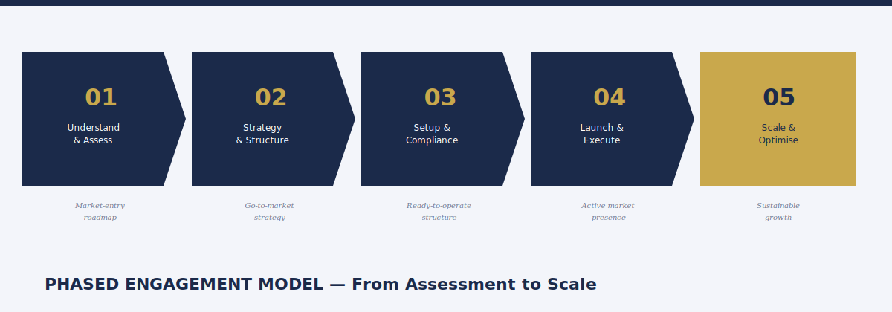

HOW WE WORK — OUR ENGAGEMENT MODEL

We follow a structured, phased engagement model that brings clarity, compliance, and consistent execution to every client relationship — from the first market assessment through to sustained scale. Every phase has defined deliverables, clear accountability, and measurable outcomes.

Phase 1 Understand & Assess
– Deep-dive briefing on the client's products, business model, and commercial objectives
– Indian market landscape analysis — size, growth trends, competitive dynamics, and key players
– Regulatory and compliance mapping specific to the industry and product category
– Risk identification — regulatory, commercial, operational, and reputational
– Feasibility and opportunity assessment with market sizing estimates
Outcome: A detailed market-entry assessment report and agreed roadmap

Phase 2 Strategy & Structure
– Market-entry and representation strategy — positioning, pricing, and go-to-market approach
– Commercial framework — payment terms, distributor margins, pricing tiers, and incentive structures
– Channel strategy — direct, indirect, or hybrid distribution model design
– Partner and distributor identification — profiling, shortlisting, and initial engagement
– Localisation plan — product adaptation, labelling, documentation, and branding requirements
Outcome: A Board-ready go-to-market strategy with phased implementation timeline

Phase 3 Setup & Compliance
– Legal entity setup — company incorporation, branch office, or project office
– Statutory registrations — GST, IEC, FSSAI, BIS, or sector-specific licences
– IP and trademark filing — brand protection under Indian trademark law
– Bank account opening, financial infrastructure, and accounting system setup
– HR framework — employment structure, offer letters, HR policy, and payroll
Outcome: A fully operational, compliant, and ready-to-launch Indian market structure

Phase 4 Launch & Execute
– Sales and marketing rollout — brand introduction, product launches, and demand generation
– Distributor and dealer onboarding — agreements, training, and initial stocking
– Trade operations activation — procurement, import/export clearance, and inventory management
– Customer acquisition — direct sales, trade shows, and channel-led growth activities
– After-sales service and warranty process implementation
Outcome: An active, commercially operational market presence with initial revenue

Phase 5 Scale & Optimise
– Geographic expansion — city, state, and regional rollout strategy and execution
– Deeper channel penetration — sub-distributor and retailer network development
– Localisation and in-country manufacturing sourcing assessment where applicable
– Performance monitoring — sales dashboards, KPI reviews, and market share tracking
– Cost optimisation — logistics, procurement, and operational efficiency improvements
Outcome: Sustainable, scalable growth with optimised cost structure and expanding share

Our Engagement Principles

Single-Window Accountability  One point of contact. One team responsible for all outcomes. No confusion over who owns what. | Compliance First  Every action begins with a compliance check. We never compromise regulatory integrity for speed or convenience.
Transparent Communication  Regular structured reporting, proactive issue escalation, and honest assessments — always. No surprises, no spin. | Performance Metrics  Every engagement is tracked against agreed KPIs. We hold ourselves accountable to measurable outcomes, not effort.

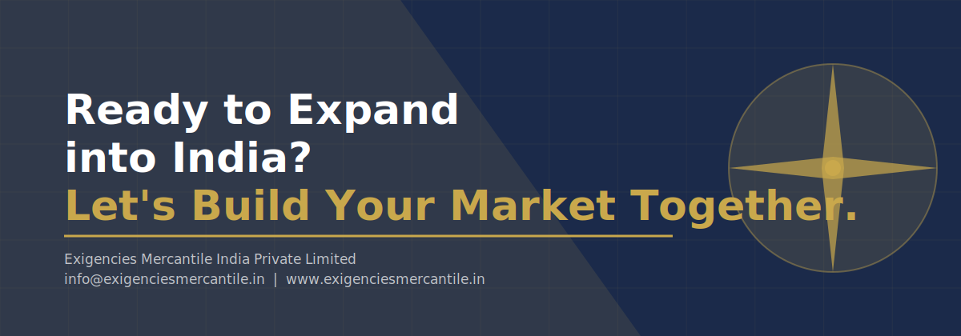

CONTACT US

We welcome enquiries from international OEMs, global enterprises, and domestic businesses seeking a trusted, structured partner in India. Whether you are exploring market entry for the first time or looking to accelerate an existing Indian operation, we are ready to engage.

Ready to Expand into India?
Let's Build Your Market Together.
Exigencies Mercantile India Private Limited
Email: info@exigenciesmercantile.in | Web: www.exigenciesmercantile.in
India · International Partnerships Welcome

HOW TO ENGAGE WITH US  Step 1: Reach out via email or our website contact form  Step 2: Initial consultation call — we understand your requirements  Step 3: We propose a structured engagement scope and timeline  Step 4: Agreement, onboarding, and commencement of Phase 1 | WE ARE YOUR RIGHT PARTNER IF YOU ARE:  ✔ An international OEM seeking authorised representation in India  ✔ A global brand planning a structured market entry  ✔ A trading enterprise looking for reliable India-based sourcing  ✔ An infrastructure company requiring equipment and service support  ✔ An investor seeking compliant commercial property in India

